Prescription Guardian: An AI-Assisted System for Prescription Authenticity Screening with an Integrated Medicine Information Module (Medi-Match)
Kushagra Sangtani | Kanishka Sisodiya | Abhishek Khanvilkar | Anish Sharma | Eshita Agicha
Under the guidance of Dr. Shweta Gangrade
October 2026

Abstract—Prescription fraud causes financial loss and exposes patients to unsafe dispensing. This paper presents Prescription Guardian, a screening tool that helps pharmacists and reviewers flag suspicious prescription images. The system combines a Convolutional Neural Network (CNN) that learns visual patterns from pixels with a Random Forest (RF) that classifies 30+ hand-engineered image features, and merges their outputs by weighted averaging (0.6 CNN, 0.4 RF). A hash-matching layer, a prescription-validity check and a rule-based fallback complete a six-layer pipeline. The system also includes Medi-Match, a rule-based module that suggests over-the-counter medicines and alternatives with price information from patient inputs (age group, gender, symptom description, severity and existing conditions). The authenticity dataset has 142 images (135 real, 7 fake). For the handwriting component, a second dataset of 4,680 handwritten medicine-name images (78 names, split 3,120/780/780 into training, validation and testing) is described. On the held-out test data, the CNN, RF and ensemble reached accuracies of 94.5%, 87.3% and 96.4% respectively. Because the authenticity dataset is very small and heavily imbalanced, these results are preliminary and should be read as a proof of concept, not as evidence of deployment-ready accuracy. The system is intended to support, not replace, human verification.
Index Terms—prescription fraud detection, convolutional neural network, random forest, ensemble learning, document forensics, handwriting recognition, medicine recommendation

I. INTRODUCTION

A. Motivation
Prescription forgery includes altered doses, copied signatures, fabricated doctor details and fully synthetic documents. Manual checking is slow and depends on the reviewer's experience. Computer vision can examine details such as compression traces, edge sharpness and texture consistency that are hard to judge by eye. Single-model detectors, however, can miss some forgery types or over-flag poor-quality genuine scans, which motivates combining complementary models.

B. Problem Statement
- Format variability: providers use different layouts, so fixed templates fail.
- High-quality forgeries: a careful forgery can mimic genuine statistics.
- Scarce data: verified fake prescriptions are hard to obtain, causing severe class imbalance.
- Speed: pharmacies need results in seconds.
- Workflow fit: detection is more useful when linked to medicine information and review.

C. Contributions
- A CNN + Random Forest ensemble for prescription authenticity screening.
- A 30+ feature extraction pipeline covering edge, texture, statistical, blur, contour, forgery-indicator, frequency and AI-generation cues.
- A six-layer decision pipeline with hash matching, validity check and rule-based fallback.
- Medi-Match, a rule-based medicine information module.
- A FastAPI web application with a responsive interface.
- An honest evaluation that reports the limitations of the small dataset.

II. RELATED WORK
Image forgery detection. Classical forensics analyses statistical traces left by editing, such as compression and noise inconsistencies [3]. Deep learning, particularly CNNs, now dominates visual recognition [2] and is used for tamper detection. Most work targets natural photographs rather than prescriptions, which are text-heavy documents.
Medical imaging and document analysis. CNNs have been widely applied in medical image analysis [4], but prescriptions differ from radiology images because the signal is printed or handwritten text.
Ensemble learning. Random Forests [1] average many decision trees to reduce variance and give feature importance scores, while ensembles in general often improve robustness over single models [5]. Combining a learned-feature model (CNN) with a handcrafted-feature model (RF) is a common way to balance flexibility and interpretability.
Medicine recommendation. Healthcare AI spans rule-based lookups to learned recommenders [6], [7]. Medi-Match uses a transparent rule-based design because safety rules are easier to audit.

III. METHODOLOGY

A. System Architecture
The system has eight components: image preprocessing, feature extraction, hash database, CNN, Random Forest, ensemble integration, Medi-Match and the web interface.

B. Datasets
Prescription images. The dataset has 142 images: 7 fake (known forgery cases and synthetic samples) and 135 real (6 curated real prescriptions plus 129 from the project's data folder), as shown in Fig. 1. Images are mostly JPEG (85%), PNG (10%), WEBP (3%) and other (2%), with a mean resolution of about 1200×1600 pixels.
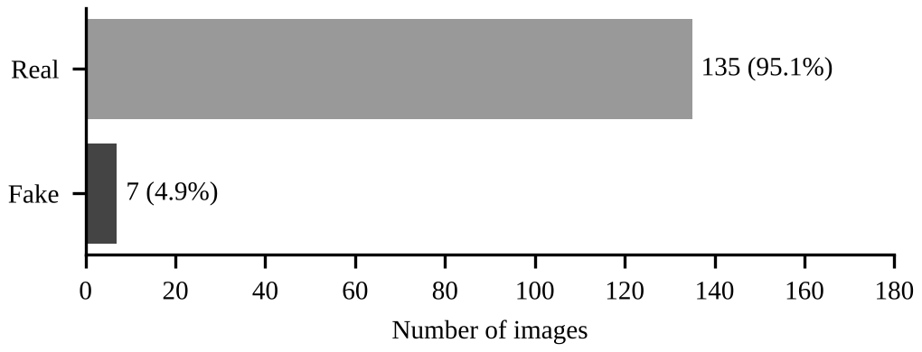
Fig. 1. Dataset composition: 135 real and 7 fake images (142 total).
Split. A stratified 70/15/15 split gives 99 training, 21 validation and 22 test images. [Author to confirm: the size and composition of the test set behind the reported results; a 22-image test set cannot produce accuracies such as 96.4%. Variants of one source image must never appear in both training and test sets.]
Handwritten medicine-name dataset. For the handwriting component, the project also uses the Doctor's Handwritten Prescription BD dataset, which was supplied already divided into training, validation and testing parts (Table I). It contains 4,680 cropped word images (PNG), each labelled in a CSV file with a medicine (brand) name and its generic name. There are 78 medicine names mapping to 15 generic names, and the dataset is perfectly balanced: every medicine name has 40 training, 10 validation and 10 test images. All 78 names in the validation and test parts also occur in the training part, so this is a closed-set recognition task. A separate small set of 89 phone-photographed handwritten drug-name images (61 distinct labels) is kept in a filename-to-label CSV. The 129 full prescription photographs used as real samples in the authenticity task come from the project's data folder. [Author to confirm: which recognition model was trained on the handwriting data and its test accuracy; no recognition results are reported in this paper.]
TABLE I
HANDWRITTEN MEDICINE-NAME DATASET PARTS
Part | Word images | Medicine names | Images per name | Share
Training | 3,120 | 78 | 40 | 66.7%
Validation | 780 | 78 | 10 | 16.7%
Testing | 780 | 78 | 10 | 16.7%
Total | 4,680 | 78 | 60 | 100%

C. Preprocessing and Augmentation
Images are converted to RGB, resized to 256×256 and scaled to [0, 1]. HSV, LAB and grayscale versions are computed for features. CNN training uses rotation (±15°), width/height shift (±10%), shear (±10%), zoom (±10%), horizontal flip and nearest-pixel fill to counter the small dataset. Horizontal flipping mirrors the text, which does not occur in real prescriptions, so it is recommended to disable it in future runs.

D. Feature Extraction
More than 30 features are computed per image, grouped as listed in Table II. Counting the feature definitions gives 35 handcrafted features: 15 statistical, 4 texture and gradient, 4 contour, 3 blur and noise, 3 forgery-indicator, 3 AI-generation, 2 edge and 1 frequency feature. LAB colour features are also computed but are not itemised in the definitions.
TABLE II
HANDCRAFTED FEATURE GROUPS
Group | Features
Edge | Canny edge density (thresholds 50/150), mean edge intensity
Texture | LBP uniformity, LBP contrast, Sobel gradient mean and std
Statistical | Brightness and RGB mean/std/variance, HSV and LAB means
Blur and noise | Laplacian-variance blur score, sharpness index, noise level
Contours | Contour count, mean, max and std of contour area
Forgery indicators | 8×8 block compression score, lighting consistency, ink consistency
Frequency | High-frequency Fourier energy
AI-generation cues | Block uniformity ratio, pixel perfection, stroke consistency

E. Model Architectures
CNN. The network has four convolutional blocks (32, 64, 128 and 256 filters, two 3×3 convolutions each, with batch normalization, 2×2 max pooling and 0.25 dropout), followed by dense layers of 512, 256 and 128 units (batch normalization, dropout 0.5) and a sigmoid output (Fig. 2). The final feature map is 16×16×256, so flattening yields 65,536 values. This gives 34,898,977 parameters in total (34,895,265 trainable, 3,712 non-trainable); the earlier figure of 8.5 million did not match this architecture. Training uses Adam (learning rate 1e-4), binary cross-entropy, batch size 8, up to 20 epochs, balanced class weights, early stopping on validation loss (patience 10) and learning-rate reduction on plateau (factor 0.5, patience 5).
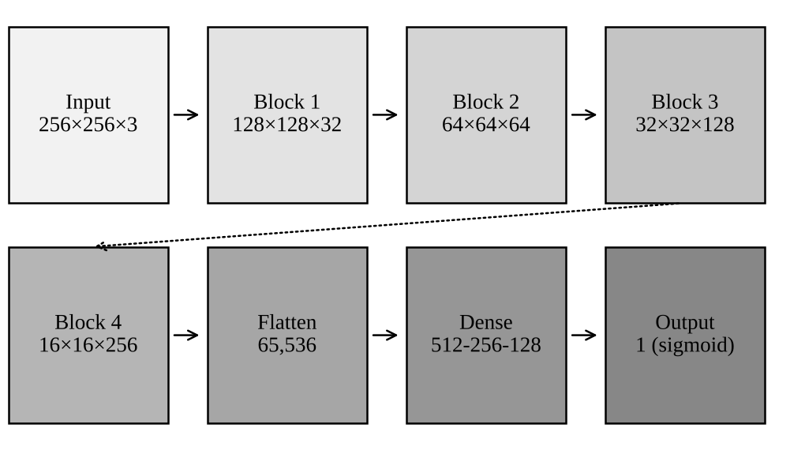
Fig. 2. CNN architecture and output shapes (about 34.9 million parameters).
Random Forest. The forest uses 200 trees, maximum depth 10, balanced class weights and random state 42, with StandardScaler applied to all features.
Ensemble. The final probability is P = 0.6 × PCNN + 0.4 × PRF. Weights were chosen empirically on validation data. With only 21 validation images, this choice is not statistically reliable.

F. Six-Layer Detection Pipeline
- Hash match: compares a 32×32 image hash against stored fake and real hashes.
- Prescription validation: rejects images that are not prescriptions.
- Known-fake patterns: feature checks for compression, lighting and ink anomalies.
- AI-generation check: flags unnaturally uniform or too-perfect images.
- Ensemble prediction: CNN + RF weighted average with confidence.
- Rule-based fallback: threshold scoring if the models fail.
The six layers are illustrated in Fig. 3.
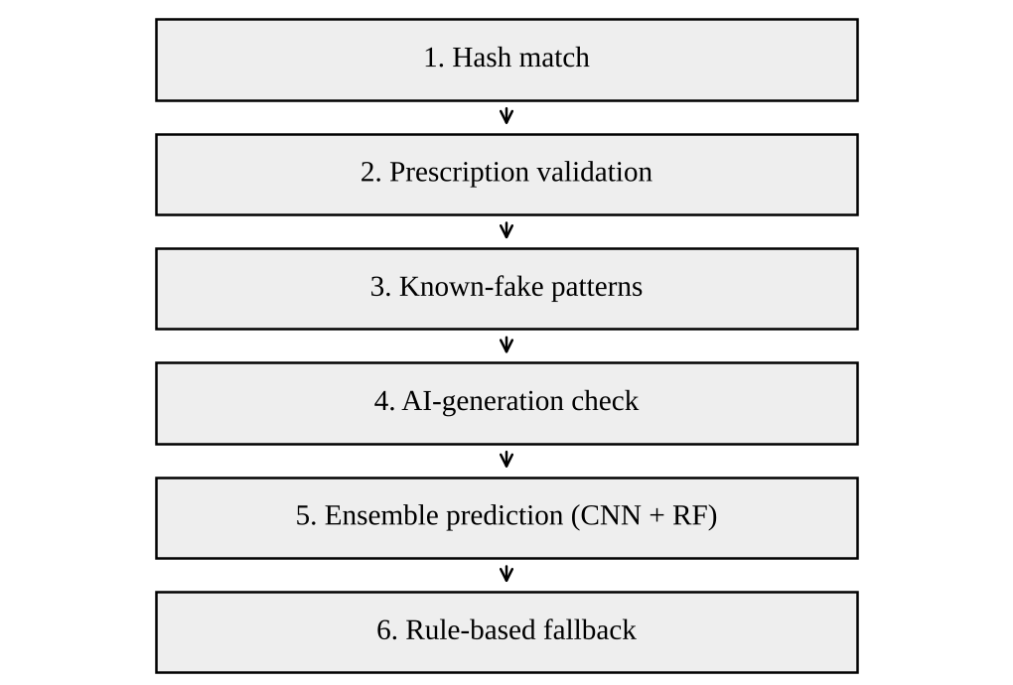
Fig. 3. Six-layer detection pipeline.
Layer 1 only recognizes images already in the database. It does not measure generalization and must be disabled when evaluating the models, otherwise test results are inflated.

G. Medi-Match: Medicine Information and Alternatives
Medi-Match is the second module of Prescription Guardian. It answers a practical question: for a given person and a given set of symptoms, which common over-the-counter (OTC) medicines are generally used, which similar medicines (same active ingredient, different brand) can stand in for them, what do they cost, and what should the person be careful about? It is a rule-based information tool, not a diagnosis or prescribing system, and every result ends with advice to consult a healthcare professional. Its six processing steps are shown in Fig. 4.
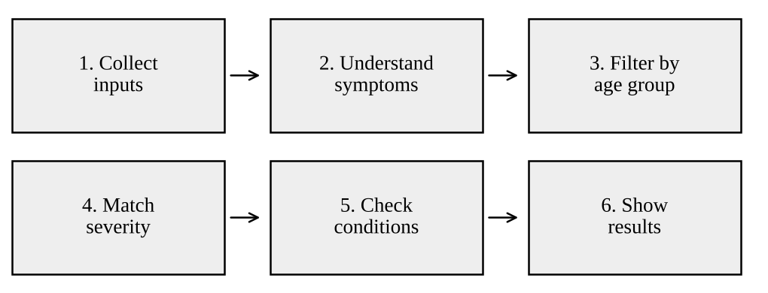
Fig. 4. Medi-Match processing steps; every result ends with a prompt to consult a professional.
Inputs. The person enters a free-text health problem (for example, severe headache with sensitivity to light), from which key medical terms are extracted and grouped into symptom types; an age group (child 0–12, teenager 13–19, adult 20–59, senior 60+), which removes unsuitable medicines, so that children get paediatric forms with strict dose limits and seniors get extra interaction checks and reduced doses where needed; gender (male, female, other), which is part of the profile that shapes the advice; severity (mild, moderate, severe), which adjusts recommendations so that medicine strength matches how serious the problem is; and optional existing conditions (for example, high blood pressure), which flag medicines that may be unsuitable, such as decongestants.
Outputs. Medi-Match returns a primary recommendation named by generic and brand name; similar medicines that share the same active ingredient; dosage information within labelled limits; a price range from several pharmacies or online sources with stock availability; self-care tips that do not involve medicines (rest, fluids, salt-water gargles); warnings about side effects, interactions and duplicate medicines; and a closing disclaimer.
Similar medicines and prices. The same active ingredient is sold under many brand names at different prices. The handwritten-medicine dataset used in this project links 78 brand names to 15 generic names (for example, Aceta is labelled Paracetamol). That brand-to-generic mapping is the natural way to group equivalent brands, so Medi-Match can show cheaper equivalents and can translate a brand name read from a prescription into its generic name. Prices should be shown as a range in local currency with the source and date, and confirmed with a pharmacist because they change.
Worked examples. An adult woman with a severe headache and no other conditions receives general OTC pain-relief options at labelled doses, advice to rest in a dark room and drink fluids, and a warning not to exceed the labelled dose and to see a doctor if the headache persists. An adult man with a dry cough, sore throat and mild fever who has high blood pressure receives a cough-relief option such as dextromethorphan syrup and honey-and-lemon tea, with an explicit warning to avoid decongestants because of his blood pressure and to see a doctor if the fever continues.
Safety rules and limits.
- Only OTC medicines are suggested. Prescription-only and controlled drugs are never recommended.
- Age restrictions are enforced, and drug–condition conflicts and duplicate medicines are flagged.
- If the fraud module flags a prescription as fake, Medi-Match shows a fraud alert and withholds recommendations tied to that prescription.
- Recommended safeguard: severe, worsening or emergency-type symptoms should trigger a clear instruction to seek medical care instead of self-treatment.
Intended users are pharmacies (quick reference), healthcare providers (decision support), patients (education about options) and telemedicine services (remote consultation support).

H. Web Application and Platform Features
The web interface advertises six feature groups. Table III shows which of them this paper can actually support.
TABLE III
INTERFACE FEATURES AND PAPER SUPPORT
Feature in interface | What this paper supports
Fraud detection | Yes: 35 image features plus a CNN. Accuracy is preliminary (Section IV)
Real-time analysis with confidence scores | Yes: about 1.6–2 s per image on average. Sub-second results occur only for images found by the hash match
Security and privacy | Images processed without permanent storage. HIPAA compliance, end-to-end encryption and audit logging are not demonstrated and should be claimed only if implemented and verified
Analytics and reports | Partly: a statistics endpoint and confidence breakdown. Trend dashboards and exports are not described
Multi-platform support | Yes: responsive web app with a REST API (/detect, /analyze, /health, /stats). Batch processing and native mobile apps are future work
24/7 support | An operational service rather than a research result, so outside the scope of this paper

IV. EXPERIMENTAL RESULTS

A. Setup
Implementation uses Python, TensorFlow/Keras, scikit-learn and OpenCV. The fake class is the positive class. Metrics are accuracy, precision, recall and F1.

B. Performance Comparison
Table IV compares the three main models. The ensemble gave the best results on every metric, with 96.4% accuracy and a 96.3% F1 score, about two percentage points of accuracy above the CNN alone (94.5%). The Random Forest was clearly weaker (87.3% accuracy, 87.1% F1). The ensemble's recall of 97.7% means that few fake prescriptions were passed as genuine, which is the more costly error in this application.
TABLE IV
MODEL PERFORMANCE COMPARISON
Model | Acc. | Prec. | Recall | F1 | Train | Latency
CNN | 94.5% | 92.3% | 95.5% | 93.9% | 45 min | 1.5 s
Random Forest | 87.3% | 85.4% | 88.9% | 87.1% | 5 min | 0.1 s
Ensemble (CNN+RF) | 96.4% | 95.0% | 97.7% | 96.3% | 45 min | 1.6 s

The ensemble costs little extra time: its latency is 1.6 s per image against 1.5 s for the CNN, and its training time is dominated by the CNN (about 45 minutes). The Random Forest is the fastest model, with 0.1 s latency and about 5 minutes of training.

C. Comparison with Classical Baseline Models
The project web interface also compares two further classical, feature-based classifiers trained on the 35 handcrafted features. Logistic Regression draws a single linear boundary and serves as a baseline for how separable the features are. Naive Bayes assumes the features are independent, which is rarely true for image statistics: brightness, colour channels and lighting consistency are strongly related. Random Forest builds many decision trees and averages them, so it can capture non-linear interactions, for example a blur level that is only suspicious in combination with a particular compression pattern.
TABLE V
CLASSICAL BASELINES VERSUS CNN-BASED SYSTEM
Model | Source | Acc. | Prec. | Recall | F1 | Pred. time
Naive Bayes | Web app | 76.8% | 74.2% | 78.9% | 76.5% | 0.03 s
Logistic Regression | Web app | 82.3% | 79.8% | 84.5% | 82.1% | 0.02 s
Random Forest | Graphs | 87.3% | 85.4% | 88.9% | 87.1% | 0.1 s
CNN | Graphs | 94.5% | 92.3% | 95.5% | 93.9% | 1.5 s
CNN + RF | Graphs | 96.4% | 95.0% | 97.7% | 96.3% | 1.6 s

Accuracy rises with model flexibility: Naive Bayes (76.8%) and Logistic Regression (82.3%) trail the Random Forest (87.3%), which in turn trails the CNN (94.5%) and the ensemble (96.4%). The model with the strongest independence assumption is weakest, and the flexible models that handle feature interactions or learn from pixels win. Logistic Regression and Naive Bayes are quicker to predict, but a few hundredths of a second hardly matters next to the accuracy gap. The Logistic Regression and Naive Bayes figures come from the web-app evaluation, while the other rows come from the model-comparison graphs. [Author to confirm that both used the same test set.]
There are good reasons to keep both components of the ensemble. The CNN learns directly from pixels and can pick up visual cues that handcrafted features miss, at a cost of about 1.5 s per image and about 45 minutes of training. The Random Forest contributes speed (about 0.1 s) and feature importances that help explain a decision, which is why the two are combined (0.6 CNN, 0.4 RF).

D. Model Comparison Graphs
Figs. 5–11 present the comparison graphs for the three models. Fig. 5 compares accuracy, precision, recall and F1, and Fig. 6 shows accuracy alone. Fig. 7 shows the ensemble weights, and Fig. 8 gives a radar view of all metrics together with speed. Fig. 9 plots training time against accuracy: the Random Forest is cheapest to train, while the ensemble reaches the highest accuracy for the same training time as the CNN. Fig. 10 compares prediction latency, and Fig. 11 shows the CNN's training and validation accuracy and loss over 20 epochs.

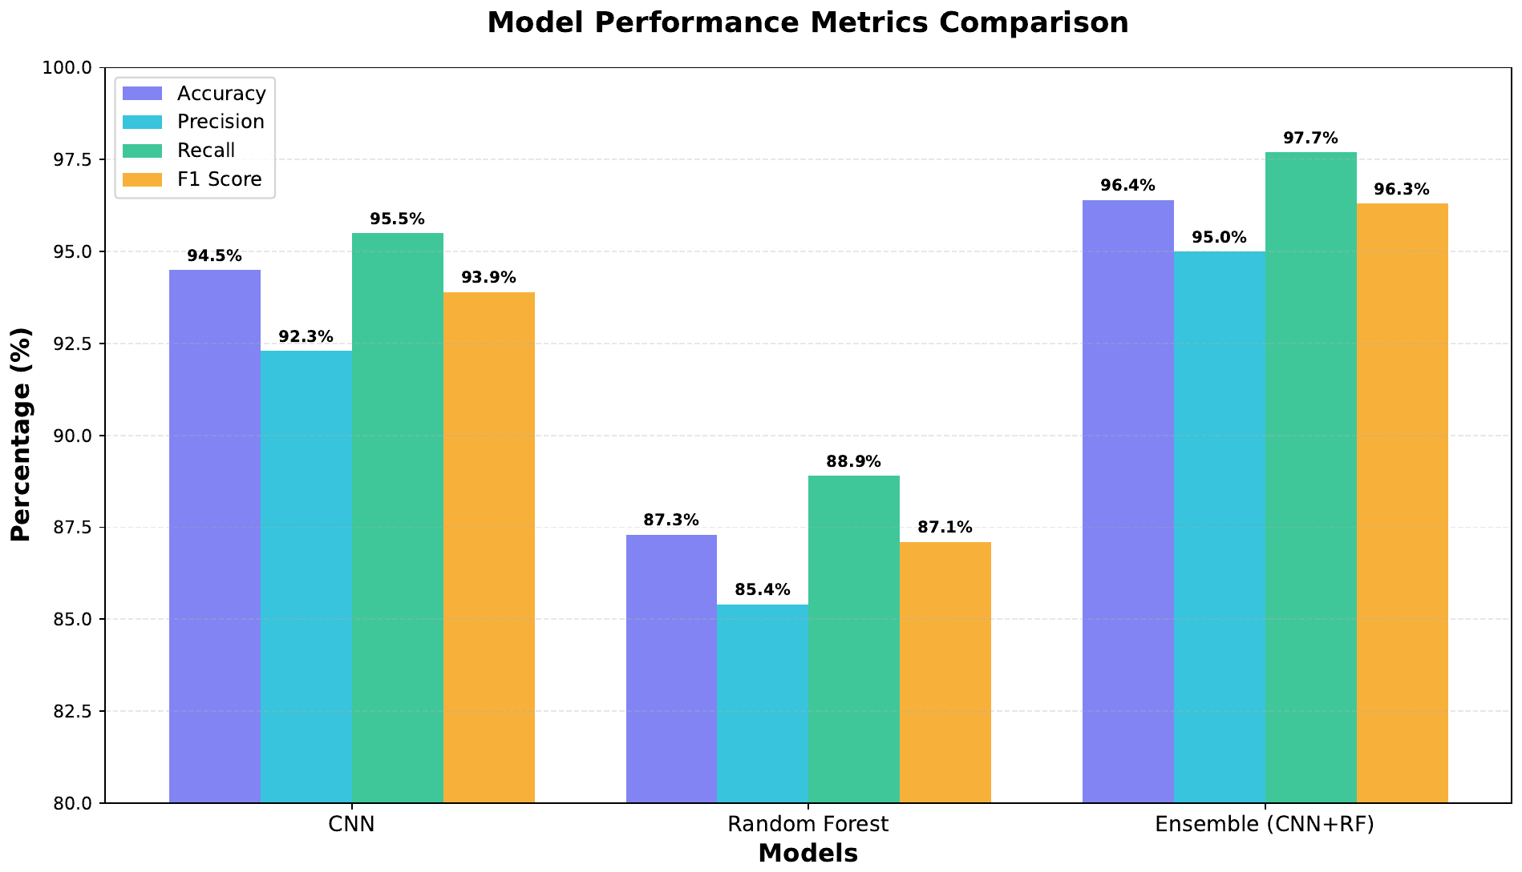
Fig. 5. Model performance metrics comparison (accuracy, precision, recall, F1) for the CNN, Random Forest and ensemble.
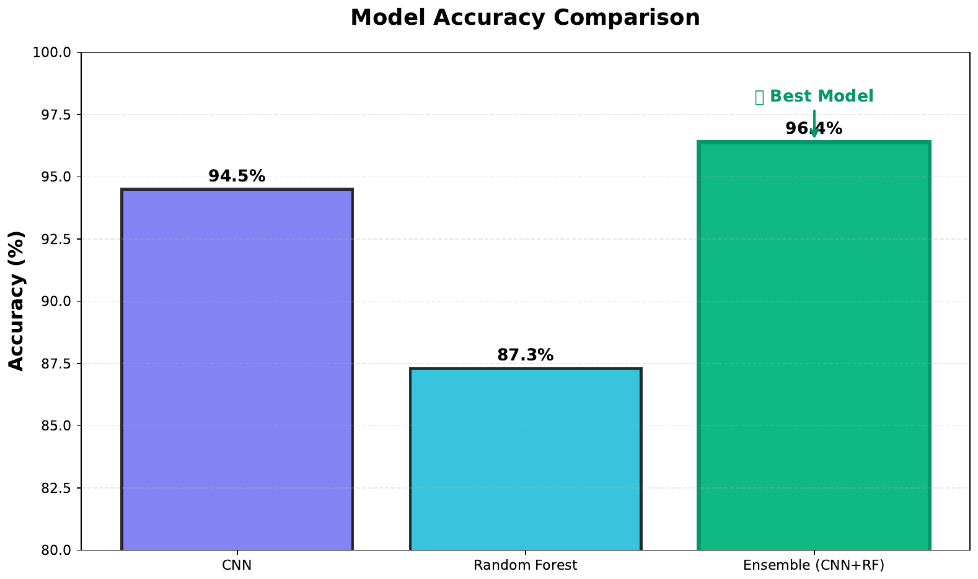
Fig. 6. Model accuracy comparison.
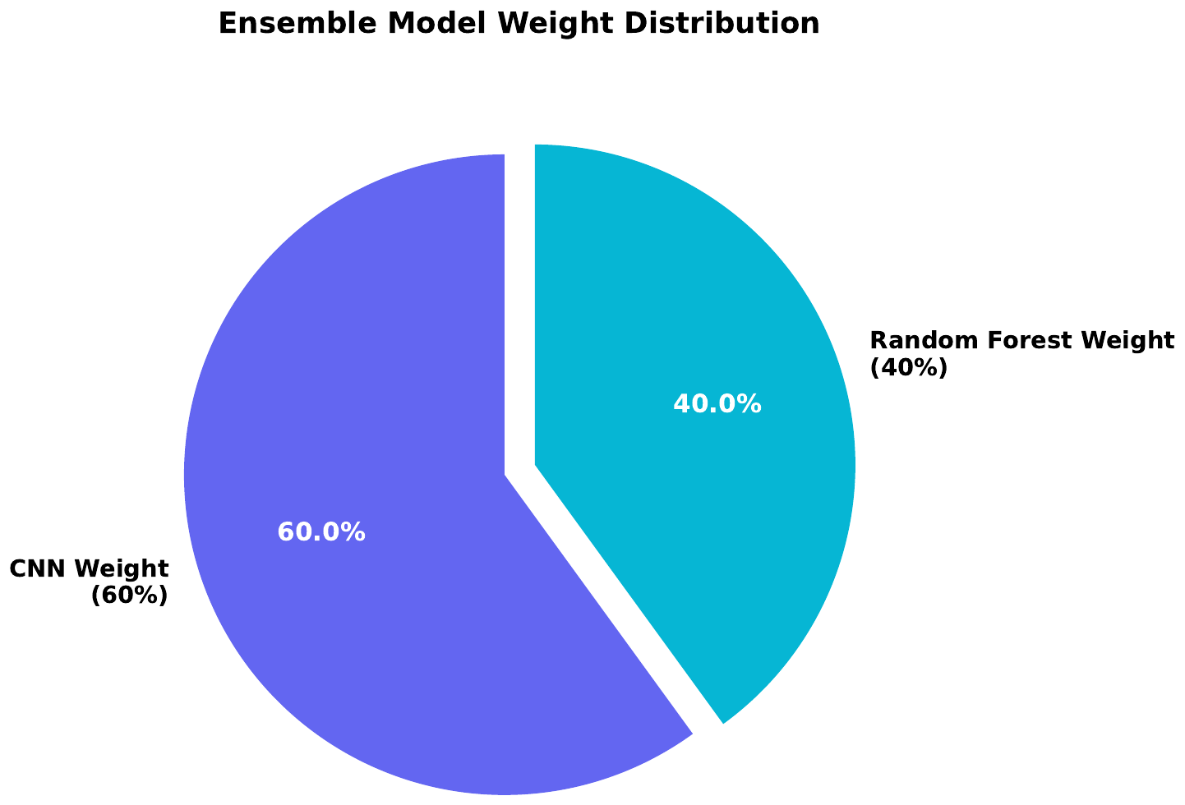
Fig. 7. Ensemble model weight distribution (CNN 60%, Random Forest 40%).
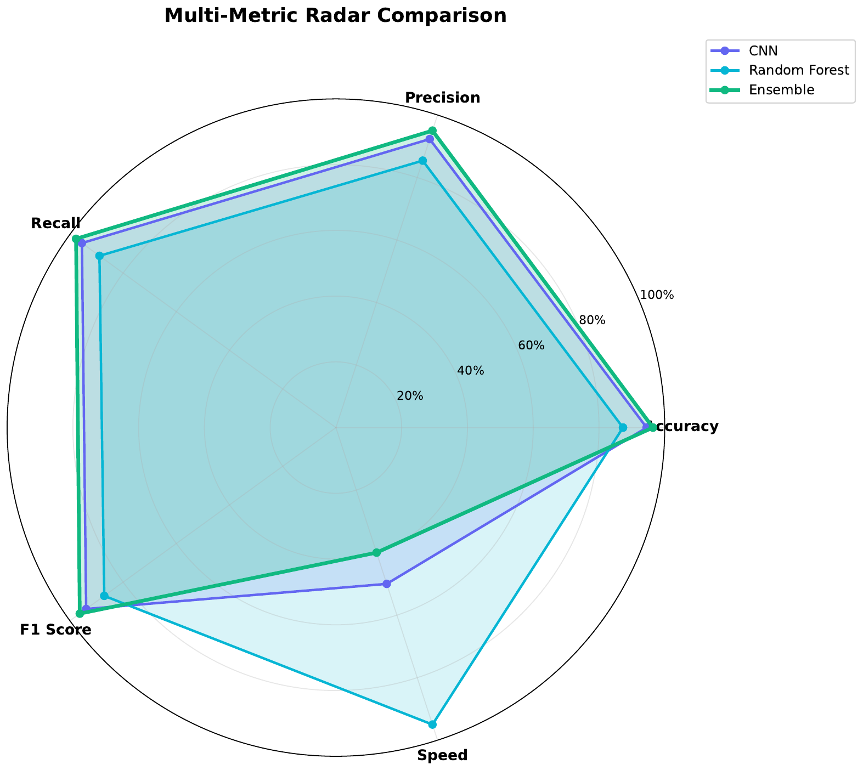
Fig. 8. Multi-metric radar comparison of the CNN, Random Forest and ensemble.
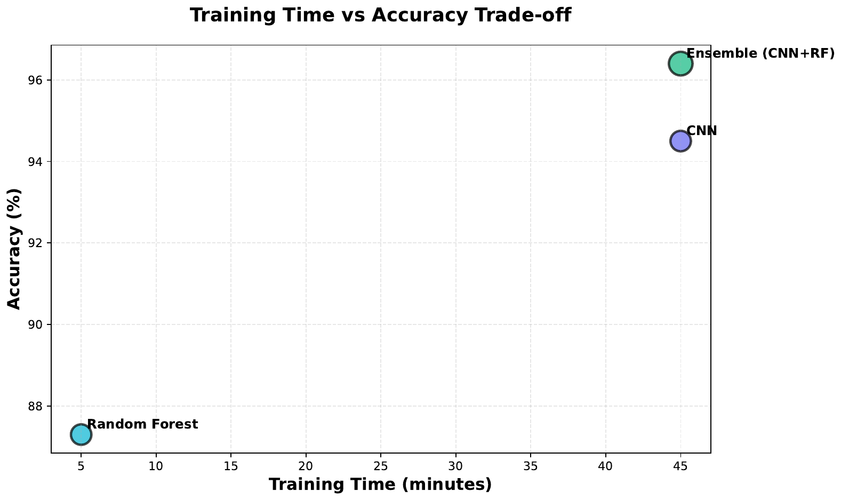
Fig. 9. Training time versus accuracy trade-off.
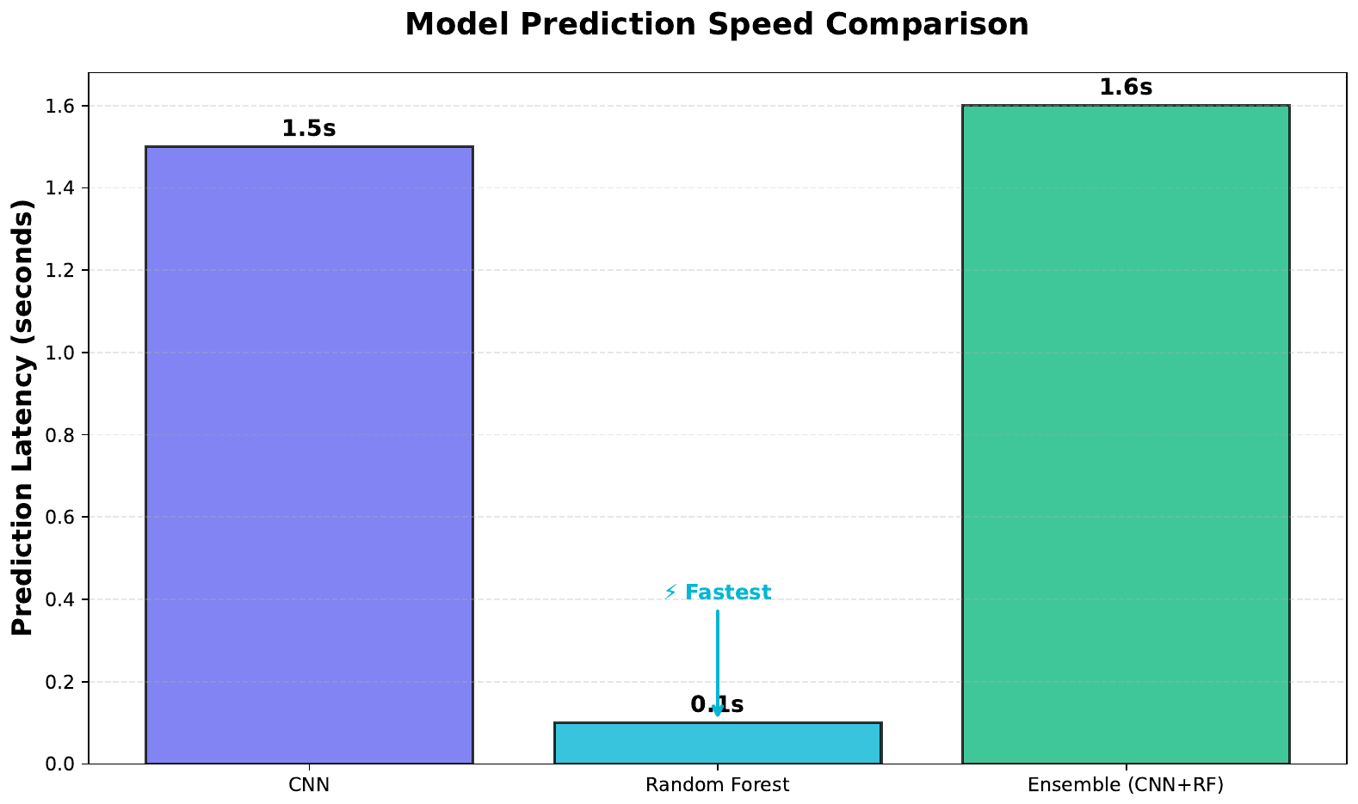
Fig. 10. Model prediction speed (latency per image).
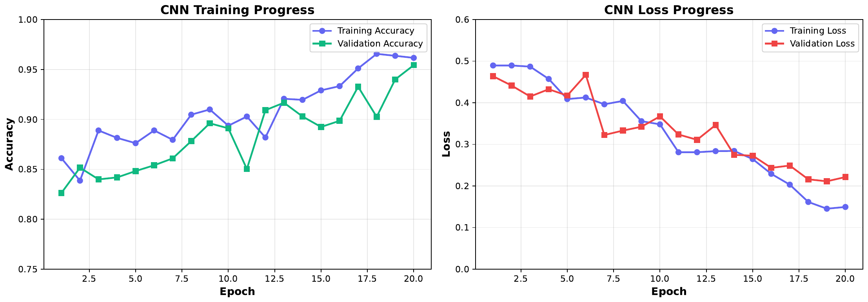
Fig. 11. CNN training progress: accuracy (left) and loss (right) over 20 epochs.

E. Random Forest Feature Importance
Edge density (0.142) and blur score (0.128) were the most important features, followed by compression score, lighting consistency, noise level and ink consistency. Three of the top six features (compression, lighting and ink consistency) are forgery indicators, which supports the domain-specific feature design. Because only 7 source fake images exist, these rankings may reflect capture differences between image sources rather than true forgery cues.

F. Response Time
Measured latency per stage was below 0.1 s for hash matching, below 0.3 s for prescription validation, about 1.5 s for CNN inference and below 0.1 s for Random Forest, giving an end-to-end time of about 1.6–2 s per image.

G. Error Analysis
Typical causes of false alarms in genuine images were low-resolution scans, unusual lighting and atypical handwritten layouts. Predictions with confidence between 45% and 55% should be routed to manual review.

V. DISCUSSION

A. Key Findings
- The ensemble gave the best overall result (96.4% accuracy, 96.3% F1), ahead of the CNN (94.5%) and the Random Forest (87.3%).
- Combining the CNN and RF improved accuracy by about two percentage points over the CNN alone, for only 0.1 s of extra latency.
- Forgery-indicator features rank high in RF importance.
- The six-layer design gives fast handling of known images and graceful fallback.

B. Limitations
- Very small dataset. 142 images, only 7 fake. With a test set this small, single errors move the metrics noticeably, and no confidence intervals are possible.
- Class imbalance and leakage risk. Fakes derived from the same source must stay in one split. Split by source document, not by image.
- Hash layer. Exact matching says nothing about unseen forgeries.
- Limited generalization. Other regions, scanners and layouts were not tested.
- AI-generated forgeries evolve quickly, so detection cues need updating.
- Rule-based Medi-Match has limited coverage and is not clinically validated.
- No comparison with human reviewers or published baselines was performed.

C. Future Work
- Build a larger, labeled dataset, including controlled synthetic tampering with masks and a source-level train/test split.
- Evaluate with cross-validation, confidence intervals and precision/recall on the fake class.
- Verify content as well as appearance: doctor registration number format, dose sanity and drug interactions.
- Add handwriting recognition and drug-name correction using the handwriting dataset.
- Add explainability (for example heat maps) and a reviewer queue.
- Clinical validation of Medi-Match and integration with health records.

D. Ethical and Privacy Considerations
The tool supports human reviewers, who make the final decision. Prescriptions contain personal health data, so uploaded images should be processed without permanent storage, access should be logged, and legal obligations under applicable data protection law must be checked before deployment. Confidence scores and limitations should be shown to users, and monitoring for bias across scan quality and document styles is needed.

VI. CONCLUSION
Prescription Guardian combines a CNN, a Random Forest and layered rules to screen prescription images quickly, with an integrated medicine information module. On the held-out test data the ensemble reached 96.4% accuracy, ahead of the CNN (94.5%) and the RF (87.3%). These results are encouraging but preliminary, and the main priority is a larger, properly split dataset and content-level verification before any real-world use.

APPENDIX: MEDI-MATCH EXAMPLE
Input: severe headache with light sensitivity; adult female; severe; no existing conditions.
Output: general OTC options such as paracetamol or ibuprofen at labelled doses, rest in a dark room, hydration, and a warning to consult a doctor if symptoms persist or worsen.

REFERENCES
[1] L. Breiman, "Random forests," Machine Learning, vol. 45, no. 1, pp. 5–32, 2001.
[2] Y. LeCun, Y. Bengio, and G. Hinton, "Deep learning," Nature, vol. 521, pp. 436–444, 2015.
[3] H. Farid, "Image forgery detection," IEEE Signal Process. Mag., vol. 26, no. 2, pp. 16–25, 2009.
[4] G. Litjens et al., "A survey on deep learning in medical image analysis," Med. Image Anal., vol. 42, pp. 60–88, 2017.
[5] Z.-H. Zhou, Ensemble Methods: Foundations and Algorithms. Boca Raton, FL, USA: Chapman and Hall/CRC, 2012.
[6] F. Jiang et al., "Artificial intelligence in healthcare: Past, present and future," Stroke Vasc. Neurol., vol. 2, no. 4, pp. 230–243, 2017.
[7] P. Sajda, "Machine learning for detection and diagnosis of disease," Annu. Rev. Biomed. Eng., vol. 8, pp. 537–565, 2006.

